

2026 ASEE MODEL DESIGN COMPETITION
Sponsored by the Two Year College Division of ASEE

Dear Colleague,

On behalf of the American Society for Engineering Education (ASEE) - Two Year College Division (TYCD), we invite you to encourage the submission of student design projects for the 28th Annual ASEE Two-College Division MODEL DESIGN COMPETITION. This event will be held in conjunction with the 2026 ASEE Annual Convention, Charlotte, North Caolina. This competition is open to 1st and 2nd year engineering and technology students at two-year and four-year colleges and universities.

As this year’s competition will be held in Charotte, NC which is a regular PGA (Pro Golf Association) tour stop at the Quail Hollow Club. The 99th PGA championship was held here in 2017. The United States will celebrate its 250th birthday on July 4, 2026, so a patriotic theme is also appropriate. This year’s contest will be to design an Autonomous Golf ball retrieval robot. The contestants will have to find a way to pick up and sort Red, White and Blue golf balls placing them in their corresponding color-coded bins. The robot must adhere to the rules of the model design competition (attached). An Exhibition session is included as part of the competition.

The main reason for this competition is for students to gain a better understanding of the design process from start to finish. Designing and building something from an idea is probably why they chose engineering in the first place. Use this design competition as a platform to reinforce their ideas and have some engineering fun! We hope to see you and your students' next June.

Sincerely, Kenny Grimes
Phone: 757-822-7278
Email: kgrimes@tcc.edu
Clint Kohl
Phone: 937-766-7672
Email: KOHLC@cedarville.edu

Geoff Berl
Phone: 585-502-8484
Email: gberl001@monroecc.edu

Previous Results from the
28th Annual ASEE Model Design Competition
June 23, 2025 – Montreal, Canada
The recent Hockey Hat-trick competition in Montreal required teams to design and build an autonomous robot to deliver 5 hockey pucks to two separate goals as fast as possible. Six teams competed and the results were as follows:
- 1st Place: Moses & Elijah Cedarville University
- 2nd Place: Glut-tony Tidewater Community College - Virginia Beach
- 3rd Place: Cyberpuck Tidewater Community College – Chesapeake

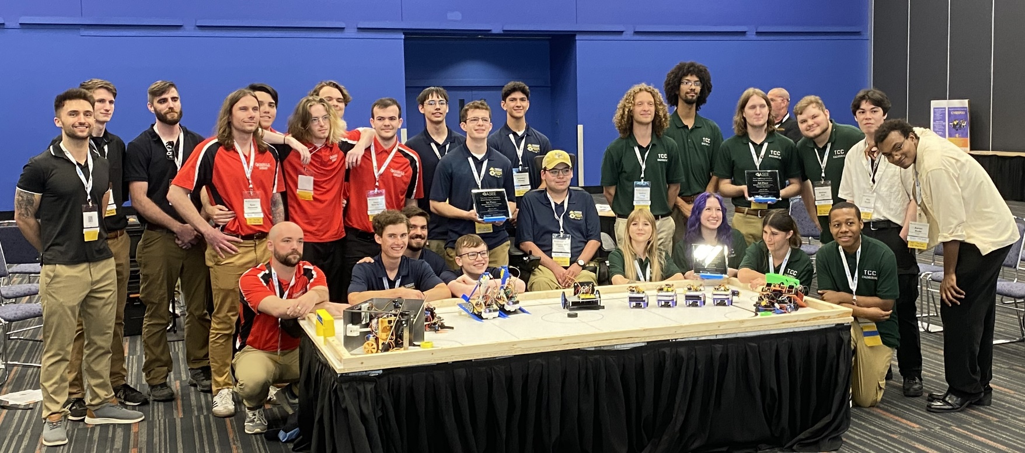

For complete results, including scores, pictures, videos, and more, visit the competition websites at ASEE Model Design Competition | Robot Research Lab
https://robotresearchlab.com/asee-model-design-competition/



2026 ASEE TYCD MODEL DESIGN COMPETITION RULES Charlotte, North Carolina

Sponsored by the Two Year College Division of ASEE
The 28th Annual Two-Year College Division (TYCD), Model Design Competition will be held in conjunction with the ASEE Annual Convention on June 21–24, 2026 in Charlotte, North Carolina.

Event Name: “Robot Range Picker”

Objective:
To design and build an autonomous robot that can successfully pick-up, sort and deposit 3 different colored randomly placed foam golf balls, in their respective colored bins. The robots have a maximum time of 120 seconds in each of their four allotted trials to deliver up to 12 golf balls as described in the ‘Robot Time Trial Scoring’ section of the rules. The robot must begin within an 8” X 12” X 10” high size limit but may expand to any size during a trial. An Exhibit Session will precede the robot trials. The judges will randomly insert the 12 golf balls (4 red, 4white, and 4 blue) into 3D printed golf ball can placed at the center of the “driving range”. Once the team has placed their robot on the field with some part of the robot touching the sorting bins, the judge will lift the can which should send the golf balls out in random directions. Once all the balls have stopped moving the judges will give the “on your mark, get set, go” and the time trial will begin.

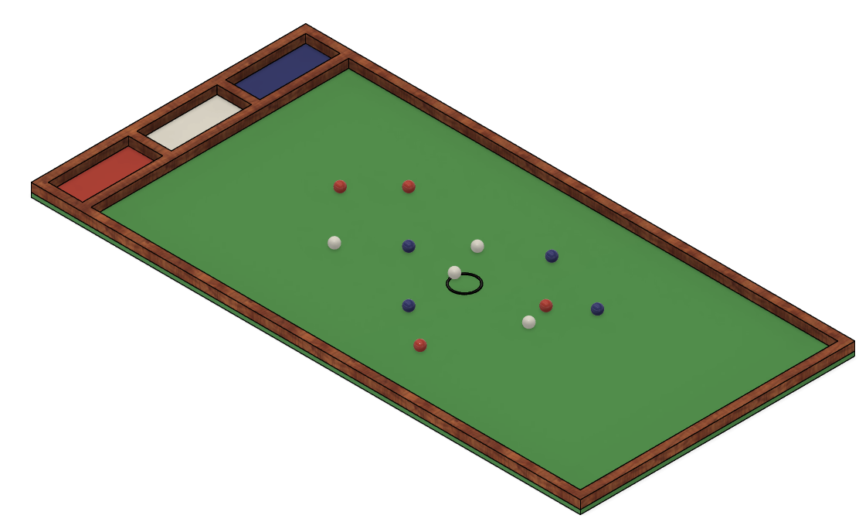
Figure 1: Isometric View of the Driving Range and Sorting Bins

Track Specifications:
- The field is formed by a ¾” thick 4’ x 8’ plywood sheet edged by 2”x2” (1.5” by 1.5” actual size) boards.
- Each of the three bins to collect the golf balls have interior dimensions of 6” by 14” (Figure 2)
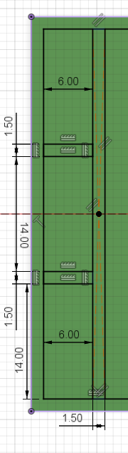
Figure 2: Track dimensions

Required Materials:
The play field (Driving Range)
- One 3/4” thick 4’ X 8’ X sheet of plywood. Since it will be covered by artificial turf the quality is not important.
- Three 2” x 2” x 96” boards (actual size 1.5” x 1.5” x 96”) to be cut into the following lengths:
  - 96” (2 boards for 8’ sides)
  - 45” (3 boards for 4’ ends and inside bin end)
- 6” (2 boards to separate the Red, White, and Blue bins.
- One Box of 2” Wood Screws (or deck screws) to attach edge boards to the driving range.
- One set of Franklin Sports Foam Practice Golf balls. See link below from Amazon.
- One 4’x8’ Artificial Grass Rug. Cut out and placed on bottom of the Driving Range
- One black sharpie to mark the center circle around the golf can on the driving range
- One 3D printed “golf ball can” to hold the balls for random placement by the judges. STL file provided.

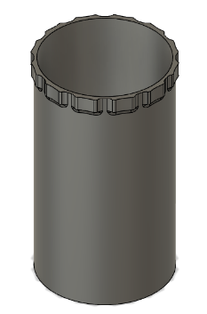
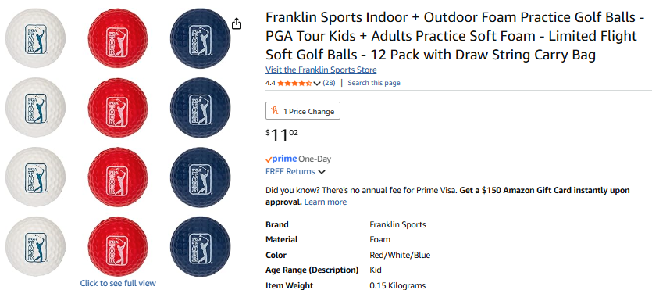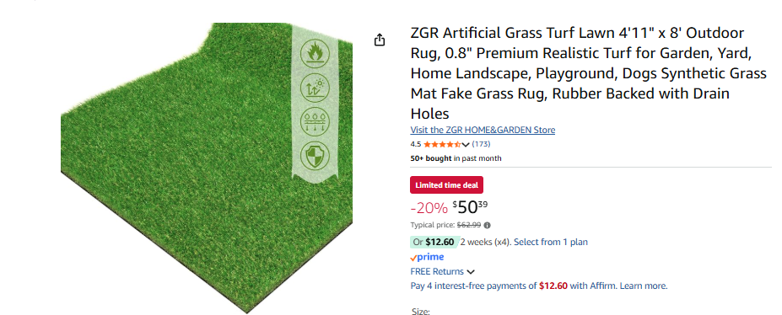

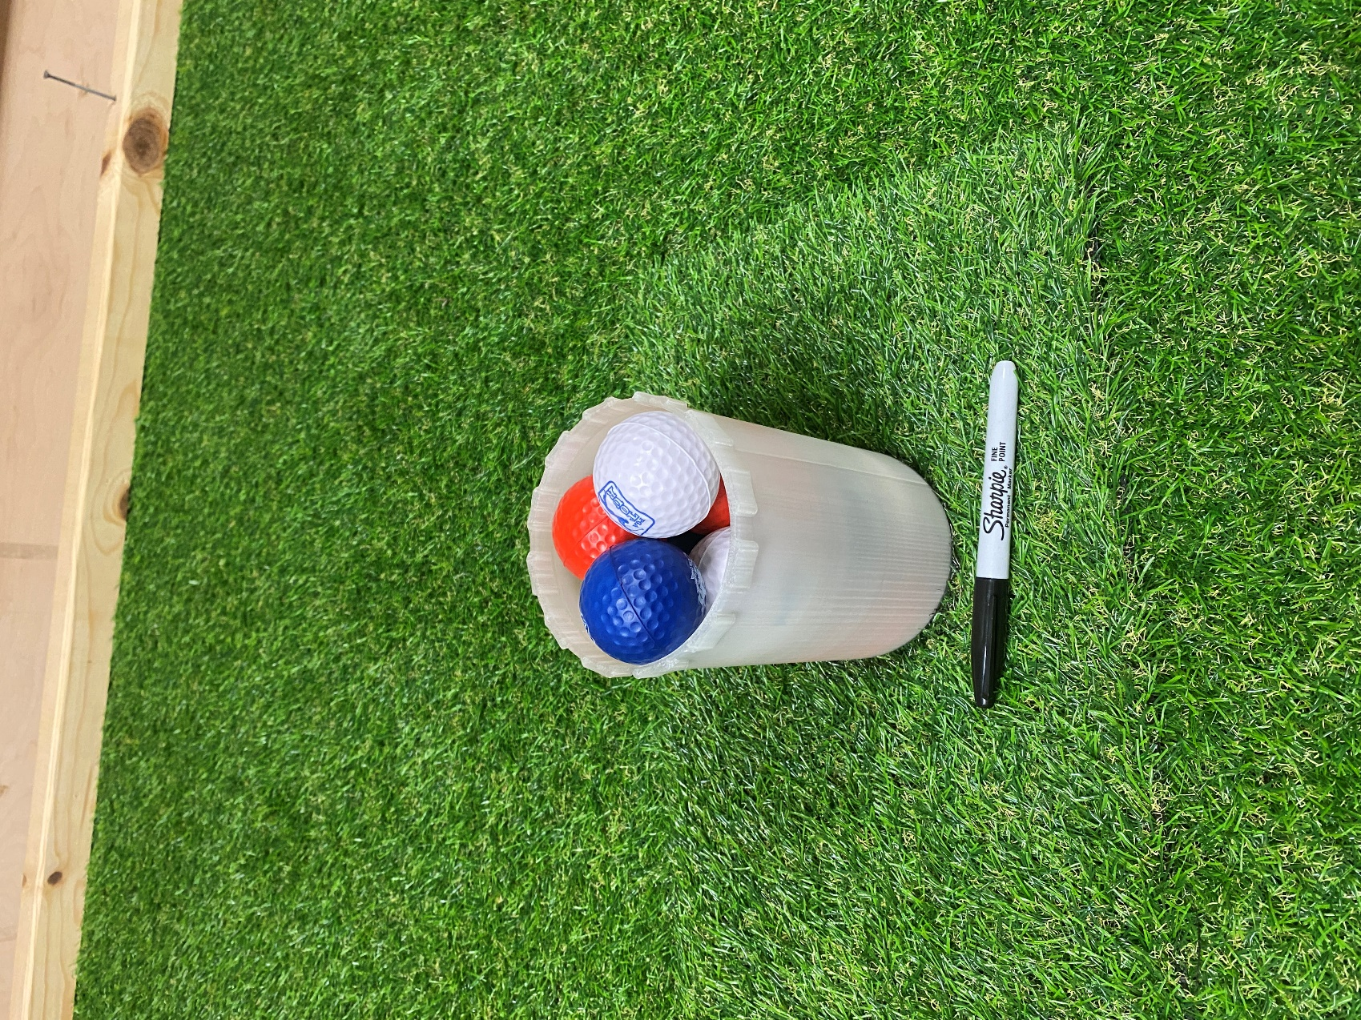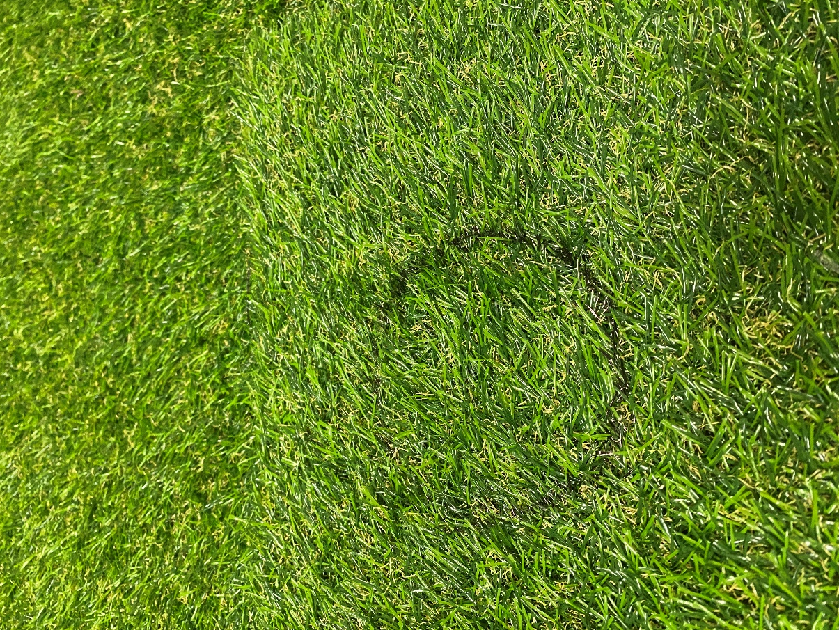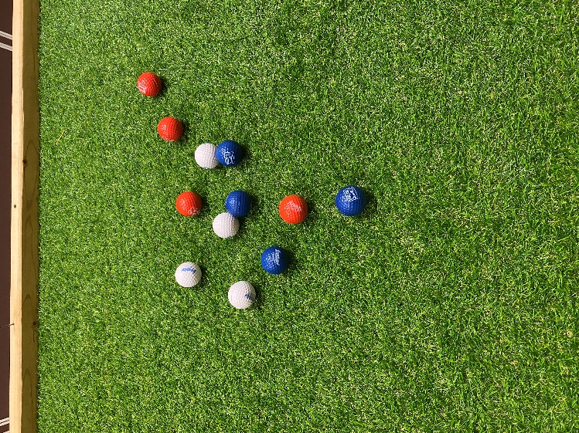
“Golf Ball Can” Black Sharpie Circle in Center of Golf Range Example distribution after lifting Golf Can

Robot Specifications:

Autonomy:
The robot is autonomous. It must perform its tasks without the aid of a human operator.

Allowable Energy Sources:
Any energy source is allowed as long as it is completely contained within the robot. Energy sources must not present any safety hazards to participants or spectators.

Prohibition Against Flying Robots:
Since the competition is held in a crowded Exhibition Hall with hundreds of spectators, flying robots (such as quad copters) are prohibited.

Maximum Robot Size:
ꞏThe robot must have an original configuration that fits inside the official sizing box. The sizing box’s interior dimensions are vertical sides of 8.0” X 12.0” and an interior height of 10.0” maximum.
ꞏThe robot may expand to any size after the start of a trial, even to the extent that it is no longer confined to initial volume constraints. The robot is not required to resume its initial configuration at the end of the trial.
ꞏAll members of a multiple robot squad must fit simultaneously in this sizing box in the configuration with which these multiple robots actually begin each trial run.
ꞏA 20-point penalty will be applied to each trial run of a robot whose initial configuration does not meet the dimensions constraints, if violated by 1/4" or less. A ‘slightly’ oversized will be permitted to compete, but with a penalty. Any robot’s initial configuration exceeding dimensional constraints beyond 1/4" will be permitted to perform, but receive a zero (0) score for each of the four trials that it arrives at the playfield in an oversized configuration.

Components, Fabrication, and Cost:
Team members using materials which are commonly available to the general public must perform all fabrication. Use of commercially available vehicles, robots, or entire kits such as RC cars, VEX, K-nex,
Fischer-Technics, Parallax or Erector sets may not be used. The use of self-programming type microcontrollers like Lego Mindstorm bricks are prohibited. Individual components from these cars, robots, or kits (except the Mindstorm Brick) may be integrated into a team’s robot as long as the majority of the robot’s components are not from the same car, robot, or kit source. The cost of purchasing all components contained on the final robot design must not exceed $600. There is no limit to development costs incurred by a team or a school.

Robot Time Trial Rules:
- It is the responsibility of the team to inspect the condition of the track before starting their robot to be certain that everything is in order. Once a team presses or pulls the start mechanism, the run counts as an official trial and may not be done over.

- While the preceding team is on the track for a trial, the on-deck team must have their robot ready to run immediately after the previous team completes their trial. Each team will have one minute to begin a trial after being called.
- All teams will be called for a trial in a current round before any teams begin the next round of testing.

- Robot sizes will be tested with the measuring box prior to each team’s first run and in subsequent runs if requested by the competition officials (judges). Team members will be responsible for placing the measuring box over their robots. If a robot fails to meet the size constraints the judges will assess a penalty proportional to the severity of the violation (See Robot Specifications).

- The golf balls will be provided by the competition officials and will be placed on the track in the center of the golf range in the 3D printed golf ball can.

- The robot must start with some part of their robot touching the wall that contains the red, white and blue bins and be within the 8” x 12” x 10” high starting envelope. The robot can be placed anywhere the team chooses along the 4’ end of the golf range being supported completely by the astroturf and not the bin walls.

- The robot may extend beyond the perimeter of the track during the trial as long as the robot is fully supported by the track surface or the perimeter boards. The robot can make contact with the wooden outer walls of the golf range but cannot damage these walls.

- The judge will ask if the team is ready to begin. At this point the can containing the golf balls will be lifted to randomly distribute them starting from the center of the range. No input from the contestants should be given to the robot about the position of the golf balls after the can is lifted. The time for a trial will begin when the judge gives the team the command to start. Once this start command is given, a team may only activate a single switch or mechanism to start the robot. Once the robot begins to move in any way, team members may not touch the robot or send commands to control it with any remote-control device.

- If a robot fails to move once the judge’s start command is given, the team members may work on their robot to get it moving but the trial timer will continue to run from the moment the start command was given. If the robot has not moved within 120 seconds of the start command, a score of zero will be assigned for that trial.

- A trial will end when any of the following actions occur:
  - The team chooses to end their run.
  - The robot has successfully deposited all the golf balls in the red, white and blue bins. The time stops when the last golf ball hits the floor of a sorting bin. (If the last ball hits another ball that is on the floor the time will not stop until all balls are touching the bins floor. The golf balls do not have to come to rest before the time stops. If a ball bounces out of a bin it would not be considered a perfect run and the time bonus will not be awarded).
  - 120 seconds elapses from the start command.

- Teams may make modifications or repairs to their robot between trials but they must be ready within one minute of being called to the track.
- Teams may not make practice runs during the Exhibit Session.
Robot Scoring:
Robots will earn points by successfully collecting golf balls and placing them in their corresponding-colored bins.

A ball is considered successfully scored when the ball is touching the bottom of the sorting bin and has come to rest. If a golf ball bounces out of a sorting bin it will earn no points.

Points earned for Red Golf balls:
10 Points for each Red Golf ball in the Red bin.
5 points for each Red Golf ball in either the Blue or White bin.
2 points for each Red Golf ball that is inside and controlled by the robot at the end of the run.

Points earned for White Golf balls:
12 Points for each White Golf ball in the White bin. It is a bit harder to score in the middle bin.
5 points for each White Golf ball in either the blue or red bin.
2 points for each White Golf ball that is inside and controlled by the robot at the end of the run.

Points earned for Blue Golf balls:
10 Points for each Blue Golf ball in the Blue bin.
5 points for each Blue Golf ball in either the Red or White bin.
2 points for each Blue Golf ball that is inside and controlled by the robot at the end of the run.

- Example of a non-perfect trial scenario impacted by all of the robot scoring rules: (all 12 balls in the red bin):
4 RED balls in the RED bin = 10pts each X 4 = 40 points
4 White balls in the RED bin = 5pts each X 4 = 20 points
4 Blue balls in the RED bin = 5pts each X 4 = 20 points
No time bonus Total = 80 points

Time Bonus points (for perfect trial runs):
If each of the 4 golf balls are successfully place in their respective colored bin a ‘perfect run’ has happened and will be awarded a bonus of (120 - trial time) which is added for every second of the 120 max allowable time that is not used.
4 RED balls in the RED bin = 10pts each X 4 = 40 points
4 White balls in the White bin = 12pts each X 4 = 48 points
4 Blue balls in the Blue bin = 10pts each X 4 = 40 points
time bonus Total = 128 points + 120-time
- Teams may make changes or repairs to their robots between trials but they must be ready within one minute of being called to the track, or have that trial score be declared zero.

Exhibit Session Scoring:
A maximum score of 120 points may be earned in the Exhibit Session. Scoring details are described below.

Overall Scoring:
The overall score for a team will be equal to the sum of the scores for the Exhibition Session and the four Robot Time Trials. A team will be disqualified from the competition if they fail to participate in the entire Exhibition Session.

Overall Score = Sum of the Points from all four Robot Time Trials + Exhibition Session Point Total

Exhibit Session:
Prior to the Robot Time Trials, each team must participate in an exhibit session where they will create a booth to promote their project to judges, other students, and conference attendees. We hope to supply each team with a 6’ long table.

All participants must be present during the entire exhibit session. Teams may use posters, written documents, physical prototypes, multimedia displays, and other visual aids at their booths. In addition, each team’s robot must remain on display at their booth for the entire duration of the exhibit session. Team members may neither work on, nor test their robots during this session.

Students from each team are required to visit the exhibits from all other schools. A captain from each school will score each team from other schools on a scale from 0-20 (20 being best) based upon the criteria that the judges will use. Each school will designate a single captain even if that school has multiple teams. The captains’ score will be computed by deleting the highest and lowest scores from the captains and then computing the average of the remaining scores.

The judges will visit each booth for approximately 10 minutes depending on the number of teams competing. During this visit, team members will guide the judges through their display for the first five minutes. In the second 5 minute period, the judges will ask the team questions. Each judge will score teams on a scale of 0 to 20 (20 being best) on the first five items below. The score in each category will be computed by deleting the highest and lowest scores from the judges, and then computing the average of the remaining scores.

- Design Development:
Guide the judges through the design process that your team followed from the initial ideas to the final solution. Describe your rationale for making design decisions.
- Robot Operation:
Discuss how your robot works.
- Fabrication Methods:
Explain how you fabricated your robot.
- Design Analysis:
Convince the judges that your design is optimal based upon its performance, cost, and environmental impact.
- Exhibit Quality:
Your exhibit quality will be judged on the following items: team and exhibit appearance, technical expertise displayed, communication skills, and effectiveness of visual aids.
- Captain Scoring:
The score from the captains will be added to the judges’ scores from the five categories above.

Typical Schedule of Events on the day of the competition:
The exact schedule may vary as the competition is subject to the scheduling needs of ASEE. A typical schedule might be as follows (but look for emails from the competition organizers for any possible time changes):
7:30 am: Report to the Exhibition Hall
  - Set up your team’s table. Identify student judge for each team.
  - Draw for the order of the presentations and time trials 8:00 – 9:00 am: Exhibit Session
  - Judges will visit each table in the order determined by the drawing
  - Team captains will visit the table of all other teams
  - The track is closed during the Exhibit Session. Teams may not work on robots or test robots at this time. 9:30 am – 11:00 am: Robot Time Trials
  - Trial 1: Each team will compete in the order determined by the drawing.
  - Trial 2: Each team will compete in the order determined by the drawing.
  - Trial 3: Each team will compete in the order determined by the drawing.
  - Trial 4: Each team will compete in the order determined by the drawing. 1:00 pm (or when the time trials end): Awards and Team Photos

Rule Interpretation Questions:
Prior to the date of the competition direct your inquiries to either of the following:
Kenny Grimes  Tidewater Community College | Geoff Berl  Monroe Community College | Clint Kohl  Cedarville University
1700 College Crescent | 1000 E. Henrietta Road | 251 N. Main St.
Virginia Beach, VA 23453 | Rochester, NY 14623 | Cedarville, OH 45314
Email: kgrimes@tcc.edu | Email: gberl001@monroecc.edu | Email: KOHLC@cedarville.edu

On the date of the competition:
The judges will interpret the intent of the rules and make all decisions. If the judges determine that a team is in violation of the intent of any rule or specification, they will deduct points in proportion to the severity of the violation. All decisions by the judges are final and may not be appealed. Teams have shown respect for the judges, participants, and spectators in the past, and this positive attitude is expected from each participant this year.

Competition Registration Questions:
Questions related to registering for the competition should be directed to: Bill Simmons
Tidewater Community College
1700 College Crescent Virginia Beach, VA 23453 Phone: 757-822-5269
Email: wsimmons@tcc.edu

Please find the entry forms on the following pages. The Interest Form should be received no later than April 1, 2026. A Registration Form for each model design team must be received no later than June 1, 2026.

PROJECT TEAM / ENTRY LIMITATIONS:

Each team must have at least one faculty advisor and at least 2 student members but no more than 10 student members. Each team member must primarily be enrolled in freshman or sophomore level classes. The number of entries from each school will be limited by the space available in the Exhibit Session. If a school has more than one entry then each team must represent a unique solution to the design problem. Multiple copies of the same solution are prohibited.

ASEE ANNUAL CONVENTION PASSES:

It is not required that student team members or faculty advisors be registered for the ASEE Annual Convention. Passes will be provided for all team members and advisors so that they can enter the conference area and exhibition area on the day of the competition. Details for obtaining passes will be made available a couple of weeks prior to the competition.

PRACTICE SESSION:
It is expected that two tracks will be ready for teams to practice on by Sunday noon. Teams should be considerate and only use the tracks for brief periods if other teams are waiting to use the tracks.
On the day of the competition the tracks will be available in the Exhibition Hall for teams to practice on prior to and following the Exhibit Session.

AWARDS:
First, second, and third-place teams will receive awards.

Revision History:
8-1-25: rev1.0 - First draft of rules, for 2026 competition.

2026 ASEE Model Design Competition Registration Form

Name of college/university:

Team Name:

Name of faculty advisor(s):

Mailing Address:

Phone:

Email (print clearly):

Student team captain:

Other student team members:

1. 2. 3.

- 5. 6.

- 8. 9.

Which students/advisors need badges for the convention center? (Badges are needed if you are not registered for the convention). Circle one: All need badges None need badges Only those listed below need badges

Will your team require electrical power at your Exhibition Table? Circle one: YES NO

Please submit this form to: Bill Simmons
Tidewater Community College 1700 College Crescent Virginia Beach, VA 23453 Phone: 757-822-5269
Email: wsimmons@tcc.edu

Return one copy of this form for each team entered by
June 1, 2026 (by US mail or email)

2026 ASEE Model Design Competition Interest Form

Name of college/university:

Name of faculty advisor(s):

Mailing Address:

Phone:

Email (print clearly):

Number of model entries desired :

Please submit this form to: Bill Simmons
Tidewater Community College 1700 College Crescent Virginia Beach, VA 23453 Phone: 757-822-5269
Email: wsimmons@tcc.edu

Return this form by April 1, 2026 (by US mail or email)

