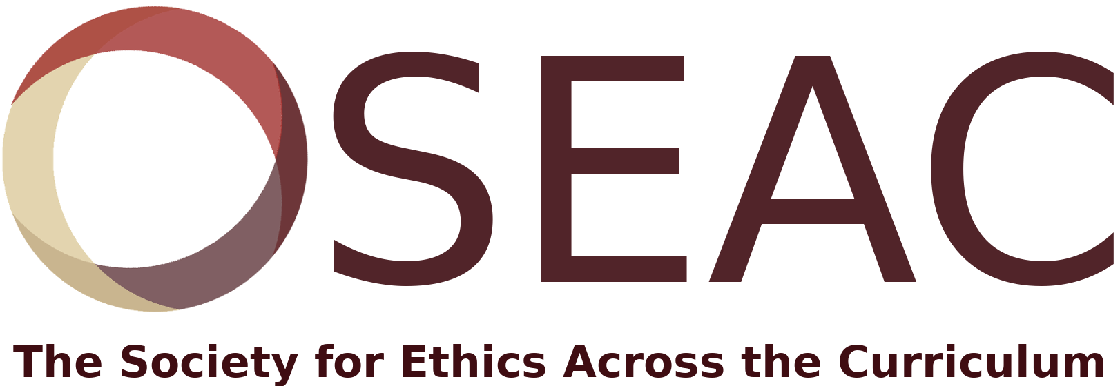

Call for Papers
22nd International Conference on Ethics Across the Curriculum
October 8 -10, 2020
Colorado School of Mines Golden, CO
Directors: Sandy Woodson, Qin Zhu, Wade Robison
Conference Theme:
Environmental Ethics

Keynote speakers:
Bill McKibben, founder of 350.org
Adam Briggle, University of North Texas
We welcome submissions addressing any aspect of teaching ethics across the curriculum. For this year’s conference we have a special interest in approaches for teaching environmental ethics, with possible topic areas including (but not limited to) climate change, food and/or water security, energy production and use, literature and the environment, development and community engagement, risk communication, animal rights, the “Green New Deal,” and environmental education, justice, policy and politics, or refugees.
Submissions are to be abstracts of no more than 250 words. Session formats include papers, panels, case study analysis and discussion, poster sessions and pedagogical demonstrations. Undergraduate and graduate students are encouraged to submit their work.

Presentations are typically 20-25 minutes in length, allowing for 5-10 minutes of Q&A. Submissions are to be formatted for blind review and submitted by August 1, 2020 via Document Management System (DMS). (Submissions must be in word doc form.) The submission template is here: https://dms.csmspace.com/SEAC/AbstractTemplate.pdf
The Society sponsors a competition for the best paper submitted by a graduate student. The winner will receive a $500 cash award and free conference registration.

The Society publishes Teaching Ethics, and conference papers may be sent to the editors for publication consideration.
For more information, contact Sandy Woodson swoodson@mines.edu

