First Year Engineering Experience Conference – First-Year Programs Division - Style Guide

Welcome to your FYEE FPD Style Guide. Please take the time to become familiar with this document as you write your paper for the FYEE Annual Conference.

This document provides guidance for how to format and organize your entire paper. It also provides information about how to properly cite sources. If you have any citation-style questions you should refer to page 30/Appendix F of the FYEE 2020 Author’s Kit

Using Predefined Styles

The style elements identified in this section have been provided to you to lend consistency to your work. Times New Roman is the preferred font. Use the following levels of this font to describe the different sections of your documents:

Title: 14-point Times New Roman Bold

Heading 1: 12-point Times New Roman Bold

Heading 2: 12-point Times New Roman Italic

Heading 3: 12-point Times New Roman

Normal: 12-point Times New Roman

Margins

8½” x 11” paper is required. Use 1-inch margins for top, bottom, left and right margins. Text should be left-justified. Do not number pages.

Line Spacing

This Style Guide requires documents to have 1.0 spacing, except for already predefined styles. You should leave one-line space between heading and body text, body text and next heading, and between paragraphs.

Paper Length

Full papers are limited to a total of 6 pages including the abstract and references. Work-in-Progress (WIP) and Workshop papers are limited to a total of 3 pages. Great Ideas for Teaching Students (GIFTS) papers are limited to 1 page. Please plan your background literature and discussion section accordingly.

Special Characters

Microsoft Word

If you are using Microsoft Word or Google Docs, you can insert special characters (e.g., ®, ©, or ™) into your manuscript by using the “Insert Symbol” function. You may insert any of the characters found in the Times New Roman Symbol/Special Characters selection windows.
More complex mathematical formulas, equations, and characters (e.g.,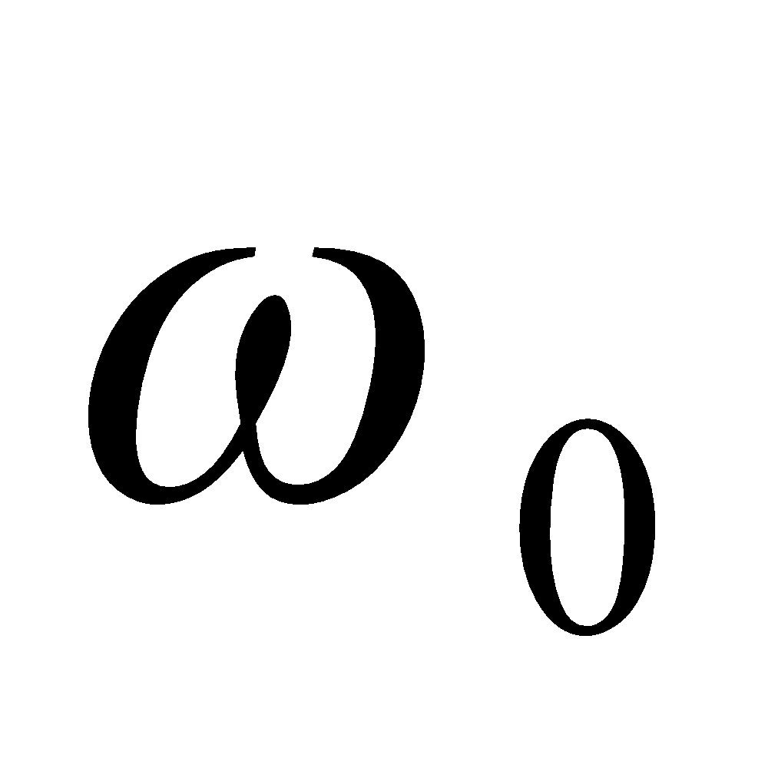) should be inserted into your manuscript using the Microsoft Word Equation Editor. If you are using Google Docs, you will likely have to create the equation in Microsoft Word’s Equation Editor or in an online LaTeX editor (e.g., https://www.codecogs.com/latex/eqneditor.php) and then copy and paste the equation into Google Docs. Please note this applies to text statements containing mathematical characters not found in the Symbol/Special Characters selection windows, as well as to the use of separate equations. See the section below on Creating Equations for further details.

Creating Equations with the Equation Editor

Formulas, equations, and text statements including special characters not found in the Symbol/Special Characters windows must be created using the Microsoft Word Equation Editor.

Important note: Proper use of your word processor’s equation editor is imperative for accurate reproduction of important mathematical symbols. Use of alternative symbol fonts native to your system (e.g., WordPerfect’s ‘Mathematical Symbols’ font) is unacceptable because these may not render appropriately on others’ screens.

Examples
Your equations should be numbered and labeled, as follows: Equation 1 shows an example of a very simple equation. Only the simplest of equations may be created with keyboard characters.

y = mx + b (1)

where:
m = slope
x = concentration
b = intercept

Most equations must be created with Microsoft Word’s symbol fonts and equation editors so that the mathematical characters always reproduce correctly. Equation 2 is an example.

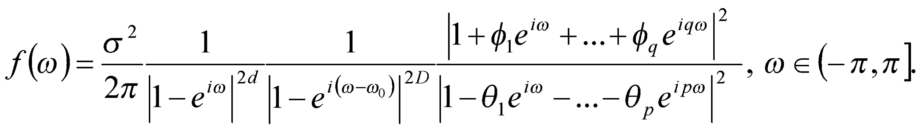 (2)

where:
= the frequency corresponding to the length of seasonality (e.g. 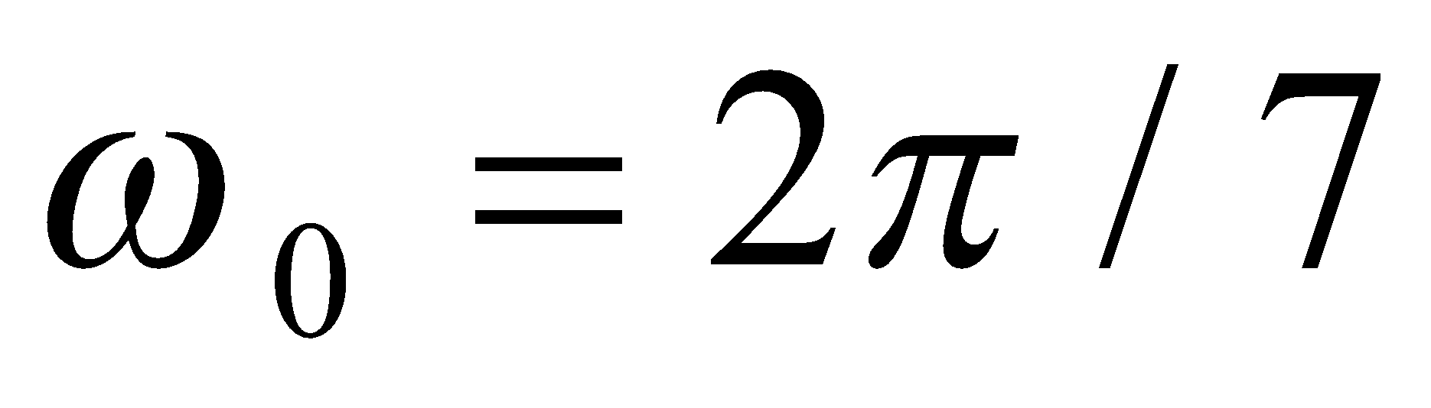 for a seven-day cycle or 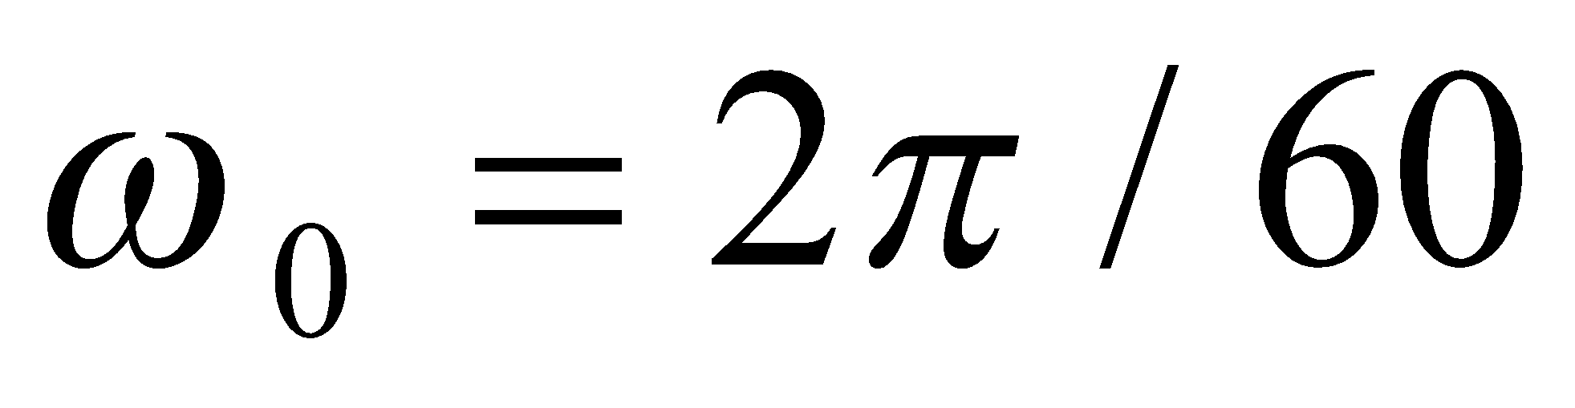 for a two-month cycle.)
D = a parameter indicating the extent of this seasonality.
The parameters of model can be estimated using the method of Anh and Kavalieris (1994).

Tables

Tables must be included as part of the text immediately after the first point of reference. DO NOT place them at the end of your paper. For improved readability, keep your tables as simple as possible. DO NOT insert any unnecessary rows or columns. It is permissible to reduce the point size from 12-point to 10-point type within large tables. All table titles/captions should be placed immediately above the table, but should be independent of the table itself. Note that the title/caption for the table should be descriptive enough that the reader should be able to understand the meaning of the table without reading the surrounding text. Tables should be formatted as follows:

Table 1. Sample Table: Format details of the heading options for FYEE papers.

Style Definition | Specifications | Used for
Title | Times New Roman, 14-pt. bold, center-justified, initial caps | Paper title.
Heading 1 | Times New Roman, 12-pt. bold, left-justified, initial caps | All level-one headings, which should include the abstract, introduction, and summary.
Heading 2 | Times New Roman, 12-pt. italics, left-justified, initial caps | All second-level headings.
Heading 3 | Times New Roman, 12-pt., left-justified, initial caps | All third-level headings.
Body | Times New Roman, 12-pt. body text, left-justified, 1.0 spacing | Note: Bold, italic, and underline typeface can be applied to body text as necessary. Body text can be bulleted or numbered lists created using the toolbar in the Word Processing program.

Any explanations of table data should immediately precede the table and be formatted as plain body text. DO NOT include table explanations within tables. Notations and references, such as superscript letters, are acceptable within the table and a legend describing notations should follow directly beneath the table.

Figures and Images

Figures include charts, graphs, drawings, and line-art. All figures and other graphics should be embedded, or electronically placed, within the text immediately after the first point of reference. DO NOT place them on separate pages at the end of your paper.

Figures must be labeled properly using Times New Roman 12-point bold font, with the X and Y axes clearly labeled, and include a legend as appropriate (see the example below). The figure caption should be Times New Roman 12-point bold font and appear immediately below the figure (centered). Note that the caption for the figure should be descriptive enough that the reader should be able to understand the meaning of the figure without reading the surrounding text.
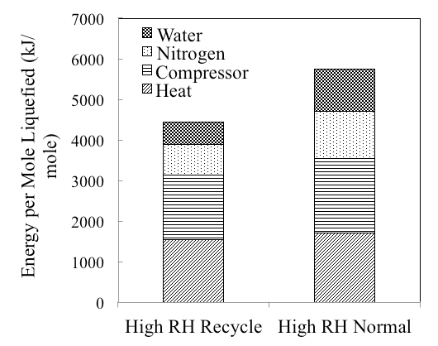
Figure 1. Sample Figure: Energy required to capture, recover, and liquefy isobutane for the Gas Recovery System operating at high relative humidity (RH) with specific energy uses denoted.

Sample Template for FYEE Annual Conference Papers

This Template portion of the Style Guide shows the document formatting standards and possible content of a conference paper. Your paper should look exactly like this Style Guide in terms of layout, margins, spacing, font, and section headings. You may delete everything prior to the word Title, below, and begin adding your own text to ensure your paper is properly formatted.

Title (Word Style: “Paper Title”). The title should accurately, clearly, and concisely reflect the emphasis and content of the paper. The title must be brief (75 characters or fewer) and grammatically correct. (Work in Progress papers must start with Work in Progress: )

Introduction (Word Style: Heading 1)

Introduction Text Style: “Normal.”
The introduction of your paper should state in approximately 400-700 words the nature of the project or problem you are addressing and why you are studying it. It should provide background information about the work and its significance, highlight other relevant literature and specify how it relates or differs from your work. The introduction also should explain the scope and limitations of your study or project.

Experimental Methods/Materials/Project Approach (Word Style: Heading 1)

Text Style: “Normal.”
The approach/experimental section should be descriptive enough for the reader to identify what was done. For research-type papers, the experimental section should provide sufficient detail to allow the work to be reproduced. Methods already published should be indicated by a reference: only relevant modifications should be described. If your paper has no experimental methods; please use appropriate titles for sections that provide details of the paper’s topic, such as background, project approach, description of technological advancements/innovations, etc.

Results and Discussion (Word Style: Heading 1)

Within the body of your paper, you can apply as many first-, second-, and third-level headings as you need. You can also include numbered and/or bulleted lists, as well as bold and italic type and superscript and subscript characters.

Here is where you show your findings, with appropriate use of figures and tables and discuss your findings, postulate explanations concerning your data, elucidate models, and compare your results with those of others. Be complete but concise. Avoid irrelevant comparisons, contrasts, or speculation unsupported by the new information presented in the paper as well as verbose discussion. Concisely discuss how your work contributes to other studies or could be improved upon in the future.

Acknowledgment (Word Style: Heading 1)

The preferred spelling of the word “acknowledgment” in America is without an “e” after the “g”. Avoid the stilted expression “one of us (R. B. G.) thanks ...”. Instead, try “R. B. G. thanks...”. Put sponsor acknowledgments in the unnumbered footnote on the first page.

References (Word Style: Heading 1)

IEEE Style should be used for all references in your paper. For more detail, consult the FYEE 2020 Authors Kit or the IEEE Editorial Style Manual (https://ieeeauthorcenter.ieee.org/wp-content/uploads/IEEE-Editorial-Style-Manual.pdf)

Below are the basic guidelines:

The template will number citations consecutively within brackets [1]. The sentence punctuation follows the bracket [2]. Refer simply to the reference number, as in [3]—do not use “Ref. [3]” or “reference [3]” except at the beginning of a sentence: “Reference [3] was the first ...”

Number footnotes separately in superscripts. Place the actual footnote at the bottom of the page in which it was cited. Do not put footnotes in the abstract or reference list. Use letters for table footnotes.

Unless there are six authors or more, give all authors’ names; do not use “et al.”. Papers that have not been published, even if they have been submitted for publication, should be cited as “unpublished” [4]. Papers that have been accepted for publication should be cited as “in press” [5]. Capitalize only the first word in a paper title, except for proper nouns and element symbols.
For papers published in translation journals, please give the English citation first, followed by the original foreign-language citation [6].

- G. Eason, B. Noble, and I. N. Sneddon, “On certain integrals of Lipschitz-Hankel type involving products of Bessel functions,” Phil. Trans. Roy. Soc. London, vol. A247, pp. 529–551, April 1955.
- J. Clerk Maxwell, A Treatise on Electricity and Magnetism, 3rd ed., vol. 2. Oxford: Clarendon, 1892, pp.68–73.
- I. S. Jacobs and C. P. Bean, “Fine particles, thin films and exchange anisotropy,” in Magnetism, vol. III, G. T. Rado and H. Suhl, Eds. New York: Academic, 1963, pp. 271–350.
- K. Elissa, “Title of paper if known,” unpublished.
- R. Nicole, “Title of paper with only first word capitalized,” J. Name Stand. Abbrev., in press.
- Y. Yorozu, M. Hirano, K. Oka, and Y. Tagawa, “Electron spectroscopy studies on magneto-optical media and plastic substrate interface,” IEEE Transl. J. Magn. Japan, vol. 2, pp. 740–741, August 1987 [Digests 9th Annual Conf. Magnetics Japan, p. 301, 1982].
- M. Young, The Technical Writer’s Handbook. Mill Valley, CA: University Science, 1989.

