Dear BED members,
Greetings -- so, you may notice that today is 12/17/2021 rather than my promised 15th distribution date. And to be honest, I have been thinking about the witty things I wanted to say as to why I was late -- like, “I was just waiting for someone to notice” or “my computer was fried and lost of my files” -- but sadly -- the actual truth is -- this week got way too busy! So, my apologies -- but the good news is, this allowed us to be sure to include a new position announcement (which actually spurred my memory) and the upcoming BEEC 20222 meeting.
In January, the BEEC will be hosting their annual meeting and have come up with a great line up to address quantitative and qualitative research in the education setting. This is a wonderful opportunity to learn more about those methodologies! Please consider attending.
I hope you all can enjoy your holidays. The newsletter will take a slight break for January 1st -- but look forward to another email January15 +/- 3 days! Happy Holidays
Be well and in good health!
Aileen Huang-Saad, BED Division Chair
The Roux Institute, Northeastern University

BED Announcements for 12/1/21
General Announcements (e.g. upcoming Webinars, upcoming seminars, upcoming grants, publication opportunities, etc.)
- CALL FOR NOMINATIONS: 2022 ASEE BED Awards
- CALL FOR NEWSLETTER CONTENT: ASEE BED Bi-monthly Newsletter
- CALL FOR PARTICIPATION: BEEC 2022

BME Education Resources for You
- FACILITATING ONLINE TEACHING: Community BME resource for online teaching
Position Announcements
- POSITION ANNOUNCEMENT: Educational Programs Manager and Instructor, Cancer Center at Illinois
- POSITION ANNOUNCEMENT: Teaching Faculty, Dept of Bioengineering, University of Illinois
- POSITION ANNOUNCEMENT: Faculty positions in engineering and comp sci (bio focus) at University of San Diego
- POSITION ANNOUNCEMENT: Tenure-track Assistant Professor of Biomedical Engineering, The Purdue School of Engineering and Technology at IUPUI

Engineering Education Research Resources
- BEEC 2022

******
General Announcements

- CALL FOR NOMINATIONS: 2022 ASEE BED Awards

Each year, the Biomedical Engineering Division (BED) of the ASEE grants several awards at the annual ASEE conference, including the Theo C. Pilkington Outstanding Educator Award, the Biomedical Engineering Teaching Award, and new this year, the Biomedical Engineering Lifetime Faculty Mentor Award.

Theo C. Pilkington Outstanding Educator Award
The Biomedical Engineering Division (BED) of ASEE annually awards The Theo Pilkington Outstanding Educator award. This award is conferred by the division for significant contributions to biomedical engineering education as evidenced by the development of successful undergraduate or graduate level programs, curricula, publications as well as by membership and activities in ASEE/BED and other biomedical engineering organizations. The award consists of a commemorative plaque and a check for $350. This award recognizes the contribution of Theo C. Pilkington as a true pioneer in Biomedical Engineering who contributed significantly to the advancement of Biomedical Engineering Education.

Biomedical Engineering Teaching Award
This award is conferred by the Biomedical Engineering Division (BED) to recognize contributions in the field of biomedical engineering education by new faculty members as evidenced by innovative teaching materials, curricula, textbooks and/or professional papers and by activity in ASEE/BED and/or other biomedical engineering organizations. Awardees must have a primary educational role in biomedical engineering, either through a dedicated BME/Bioengineering program or through a related engineering program. Faculty members who have no more than 5 years (by June 1 of the year in which the award is given) of teaching experience with primary course responsibility at the university/college or community college level are eligible for this award. The award consists of $350 and a commemorative plaque.

Biomedical Engineering Lifetime Faculty Mentor Award
The Biomedical Engineering Lifetime Faculty Mentor Award is made to a faculty member in the ASEE Biomedical Engineering Division in recognition of excellence in mentoring other faculty in biomedical engineering education. This award will be given biennially, and is conferred by the division for strong evidence of excellence in mentoring other faculty to advance their careers in engineering education or related fields, as well as for clear evidence of impact on current or former mentees both within and outside the home institution. All BED faculty members that have had active ASEE and BED memberships for 5 of the last 10 years are eligible to receive this award. Minimum activity includes conference attendance and serving as a paper reviewer. This award consists of a commemorative plaque and a check for $350.

The Awards Committee is soliciting nominations for these three awards. Note that all award winners are typically required to attend the Awards Banquet held during the ASEE Annual Conference. This year, the 2022 Annual Conference will be held in Minneapolis, MN (6/26/22-6/29/22). Before nominating an individual, please ensure that they will be available to attend (more details TBD). For detailed nomination instructions and forms, please visit the following link:
https://www.asee.org/membership-and-communities/awards-and-honors/other-divisions#Biomedical_Engineering_Division

APPLICATION PROCESS:
On or before January 15, 2022: Signify your intent to nominate by filling out the brief form at this link:
https://forms.gle/PGgaav52bni4veLX6

On or before February 15, 2022: Submit a complete nomination package (additional information will be sent to nominators).

If you have any questions, please contact the BED Awards Chair at asee.bedawards@gmail.com

- CALL FOR NEWSLETTER CONTENT: ASEE BED Bi-monthly Newsletter

As of 2021, the ASEE BED has started to share a bi-monthly newsletter with the community. We share general resources, BME Education Resources for Students and Faculty, Upcoming Positions, Engineering Education Research Resources. Information will be shared in consecutive emails. If you have information to share with the community, please send your announcement to the BED listserv, as a a 2-3 paragraph description including any relevant URLs and contact info as well as a subject line. Do not include any attachments. Be sure that the announcement includes the person to contact with questions. Email all of this information to Aileen Huang-Saad at a.huang-saad@northeastern.edu with [BED Announcement] in the subject line to facilitate email sorting. Announcements will be sent out on the 1st and 15th of each month. Each set of announcements will be included in the announcements email twice. Announcements will also be recorded on the BED website (https://sites.asee.org/bed/) and HUB (https://aseehub.asee.org/groups/home/34#active-group-members).

- CALL FOR PARTICIPATION: BEEC 2022 - Register Here

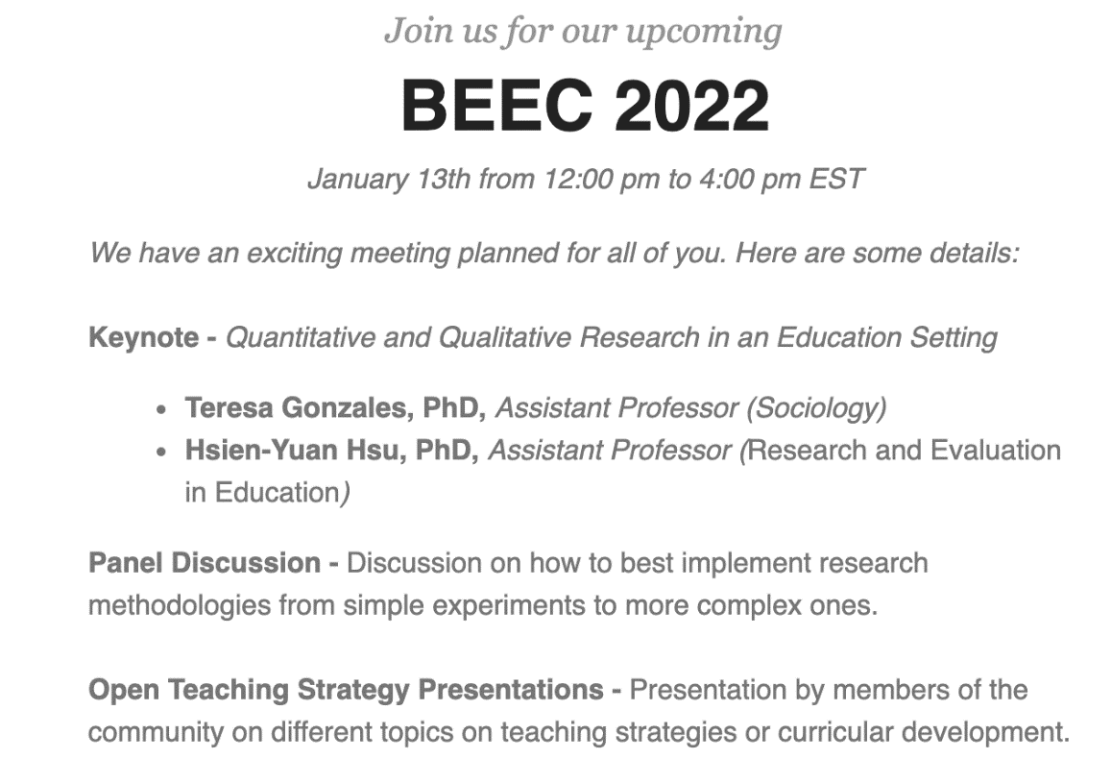

BME Education Resources for You

- FACILITATING ONLINE TEACHING: Community BME resource for online teaching

Position Announcements

- POSITION ANNOUNCEMENT: Educational Programs Manager and Instructor, Cancer Center at Illinois

The Cancer Center at Illinois (CCIL) has an extensive set of educational programs spanning high school students through professionals and continues to identify opportunities to enhance the education of trainees through creation of new programs, courses, experiences, etc. To support these ongoing and new efforts, CCIL invites applications for an Educational Programs Manager and Instructor who will work closely with the Cancer Research Training and Education (CRTEC) team and support program management, offering of courses/labs, and connection to our community through outreach.

- POSITION ANNOUNCEMENT: Teaching Faculty, Dept of Bioengineering, University of Illinois

The Department of Bioengineering (BIOE) at the University of Illinois Urbana-Champaign (UIUC) invites applications for an open rank, full-time teaching position in all areas of bioengineering. Candidates will be considered for a teaching track faculty position at the assistant, associate, or full professor rank. Alternatively, an appointment as an instructor or lecturer will also be considered when appropriate. We seek highly qualified applicants with a strong commitment to excellence in teaching and the ability to teach at all levels. The Department of Bioengineering is committed to creating an accessible, supportive environment and an educational experience that recognizes diversity and cultural competence as integral components of academic excellence. Candidates who can contribute to that goal are encouraged to apply and to identify their strengths in this area. This is a 100% non-tenure-track, renewable appointment on an academic year (nine-month) service basis paid over twelve months.

https://jobs.illinois.edu/academic-job-board/job-details?jobID=155873&job=the-grainger-college-of-engineering-teaching-faculty-open-rank-bioengineering-155873

- POSITION ANNOUNCEMENT: Faculty positions in engineering and comp sci (bio focus) at University of San Diego

The Shiley-Marcos School of Engineering at University of San Diego invites applications for a cluster of faculty to fill positions in engineering and computer science. We are seeking faculty who will work in support of USD’s vision by working as teacher-scholars to address humanity’s urgent challenges and develop the next generation of changemaking engineers. The cluster is expected to include candidates from electrical engineering, mechanical engineering, and computer science and may include candidates from other engineering disciplines (such as biomedical engineering). We have a preference for hiring tenure-track faculty at the assistant or associate professor level and professors of practice. The ad was posted on Nov. 16, and rolling reviews will begin on Dec. 1 with Zoom interviews anticipated to begin in early January.

More details about the cluster and each department's needs can be found here: https://jobs.sandiego.edu/cw/en-us/job/494760/engineering-and-computer-science-faculty

Questions can be directed to Diana Chen (dianachen@sandiego.edu).

- POSITION ANNOUNCEMENT: Tenure-track Assistant Professor of Biomedical Engineering, The Purdue School of Engineering and Technology at IUPUI

The Purdue School of Engineering and Technology at Indiana University Purdue University Indianapolis (IUPUI) is searching for a tenure-track assistant professor of biomedical engineering to start in fall 2022. Candidates must hold a doctoral degree in Biomedical Engineering or a related discipline, with research interests and demonstrated accomplishments in areas including, but not limited to, biosignals and systems, biomechanics and biomaterials, and/or therapeutic delivery and cancer engineering. More information about the position and the application requirements can be found in the job posting.

Engineering Education Research Resources

- BEEC 2022: The upcoming BEEC meeting will have some great speakers addressing education research methods -- Quantitative and Qualitative Research in an Education Setting. Definitely consider attending.
https://publish.illinois.edu/beecvirtual/beec-2022-keynote-and-panel-bios/

To send an announcement to the BED listserv, please prepare a 2-3 paragraph description including any relevant URLs and contact info as well as a subject line. Do not include any attachments. Be sure that the announcement includes the person to contact with questions. Email all of this information to Aileen Huang-Saad at a.huang-saad@northeastern.edu with [BED Announcement] in the subject line to facilitate email sorting. Announcements will be sent out on the 1st and 15th of each month. Each set of announcements will be included in the announcements email twice. Announcements will also be recorded on the BED website (https://sites.asee.org/bed/) and HUB (https://aseehub.asee.org/groups/home/34#active-group-members).

